1. Creating the tables

/* Create tables */

CREATE TABLE Studio (

--Columns for the Studio table

StudioID int identity,

StudioName char(50) not null

--Constraints on the Studio Table

CONSTRAINT PK_Studio PRIMARY KEY (StudioID)

);

--End Creating the Studio table

CREATE TABLE Film (

--Columns for the Film table

FilmID int identity,

Title char(50) not null,

StudioID int not null

--Constraints on the Film Table

CONSTRAINT PK_Film PRIMARY KEY (FilmID),

CONSTRAINT FK1_Film FOREIGN KEY (StudioID) REFERENCES Studio(StudioID)

);

--End Creating the Film table

CREATE TABLE Actor (

--Columns for the Actor table

ActorID int identity,

FirstName char(30) not null,

LastName char(30) not null,

DOB datetime

--Constraints on the Actor Table

CONSTRAINT PK_Actor PRIMARY KEY (ActorID)

);

--End Creating the Actor table

CREATE TABLE FilmCast (

--Columns for the FilmCast table

FilmCastID int identity,

FilmID int not null,

ActorID int not null

--Constraints on the FilmCast Table

CONSTRAINT PK_FilmCast PRIMARY KEY (FilmCastID)

CONSTRAINT FK1_FilmCast FOREIGN KEY (FilmID) REFERENCES Film(FilmID),

CONSTRAINT FK2_FilmCast FOREIGN KEY (ActorID) REFERENCES Actor(ActorID)

);

--End Creating the FilmCast table

2. Creating the ODBC Data Source

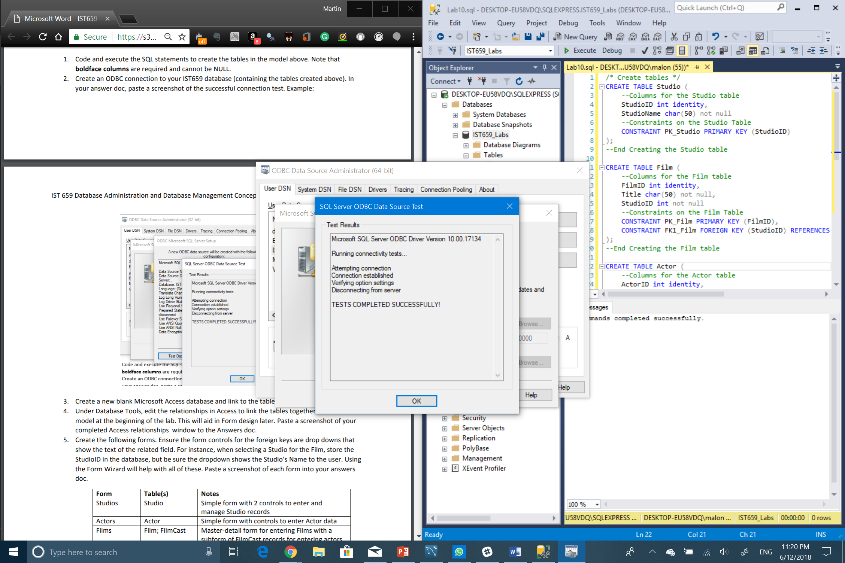

3. Creating the Table connection in MS Access

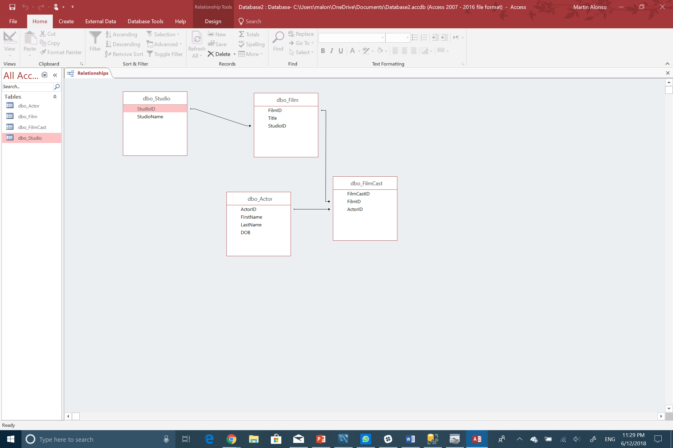

5. Creating the Forms

a. Studio

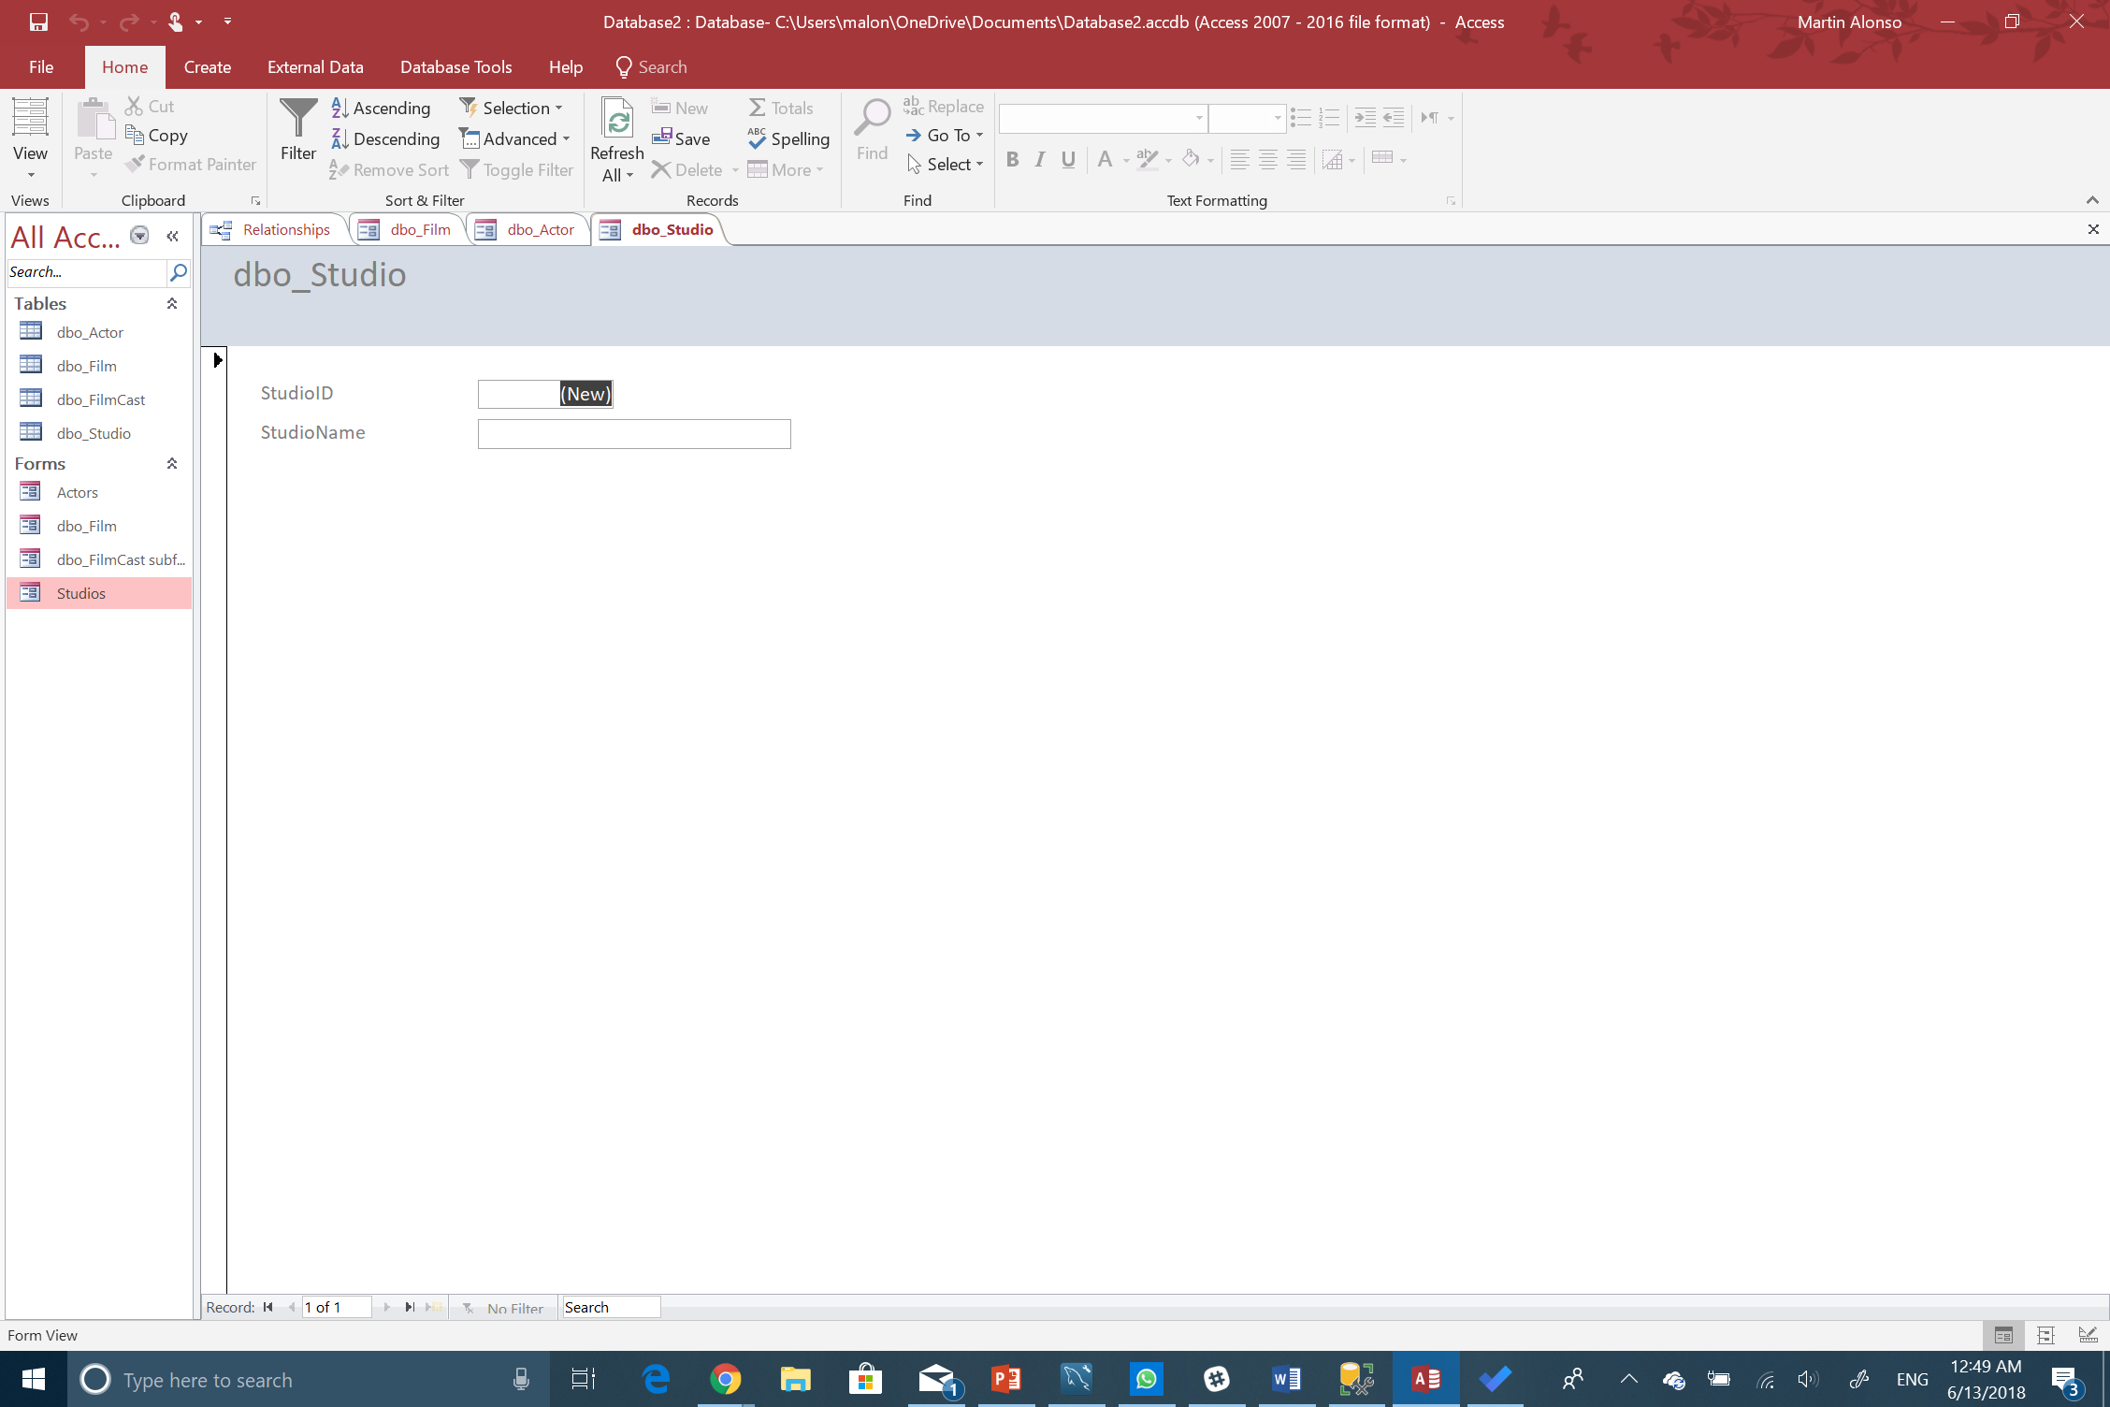

b. Actor

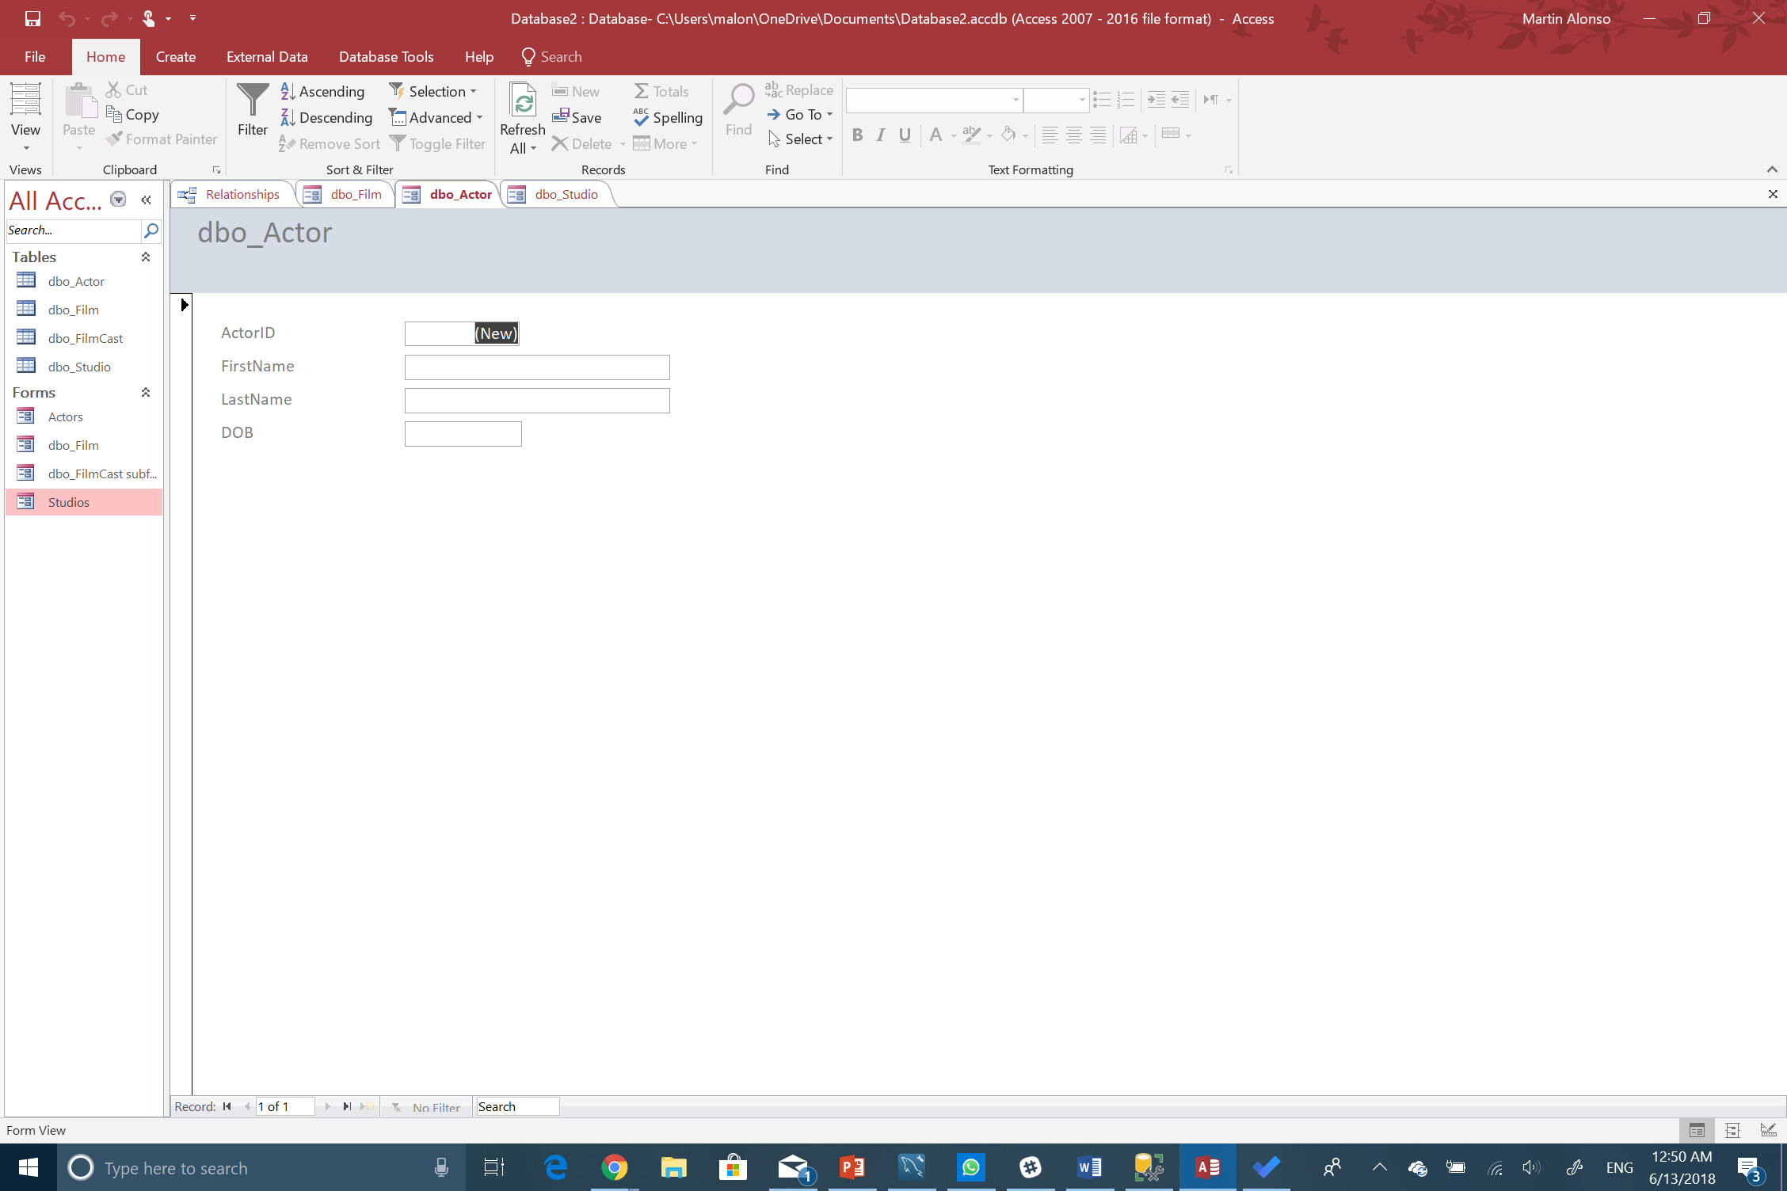

c. Film and FilmCast subform

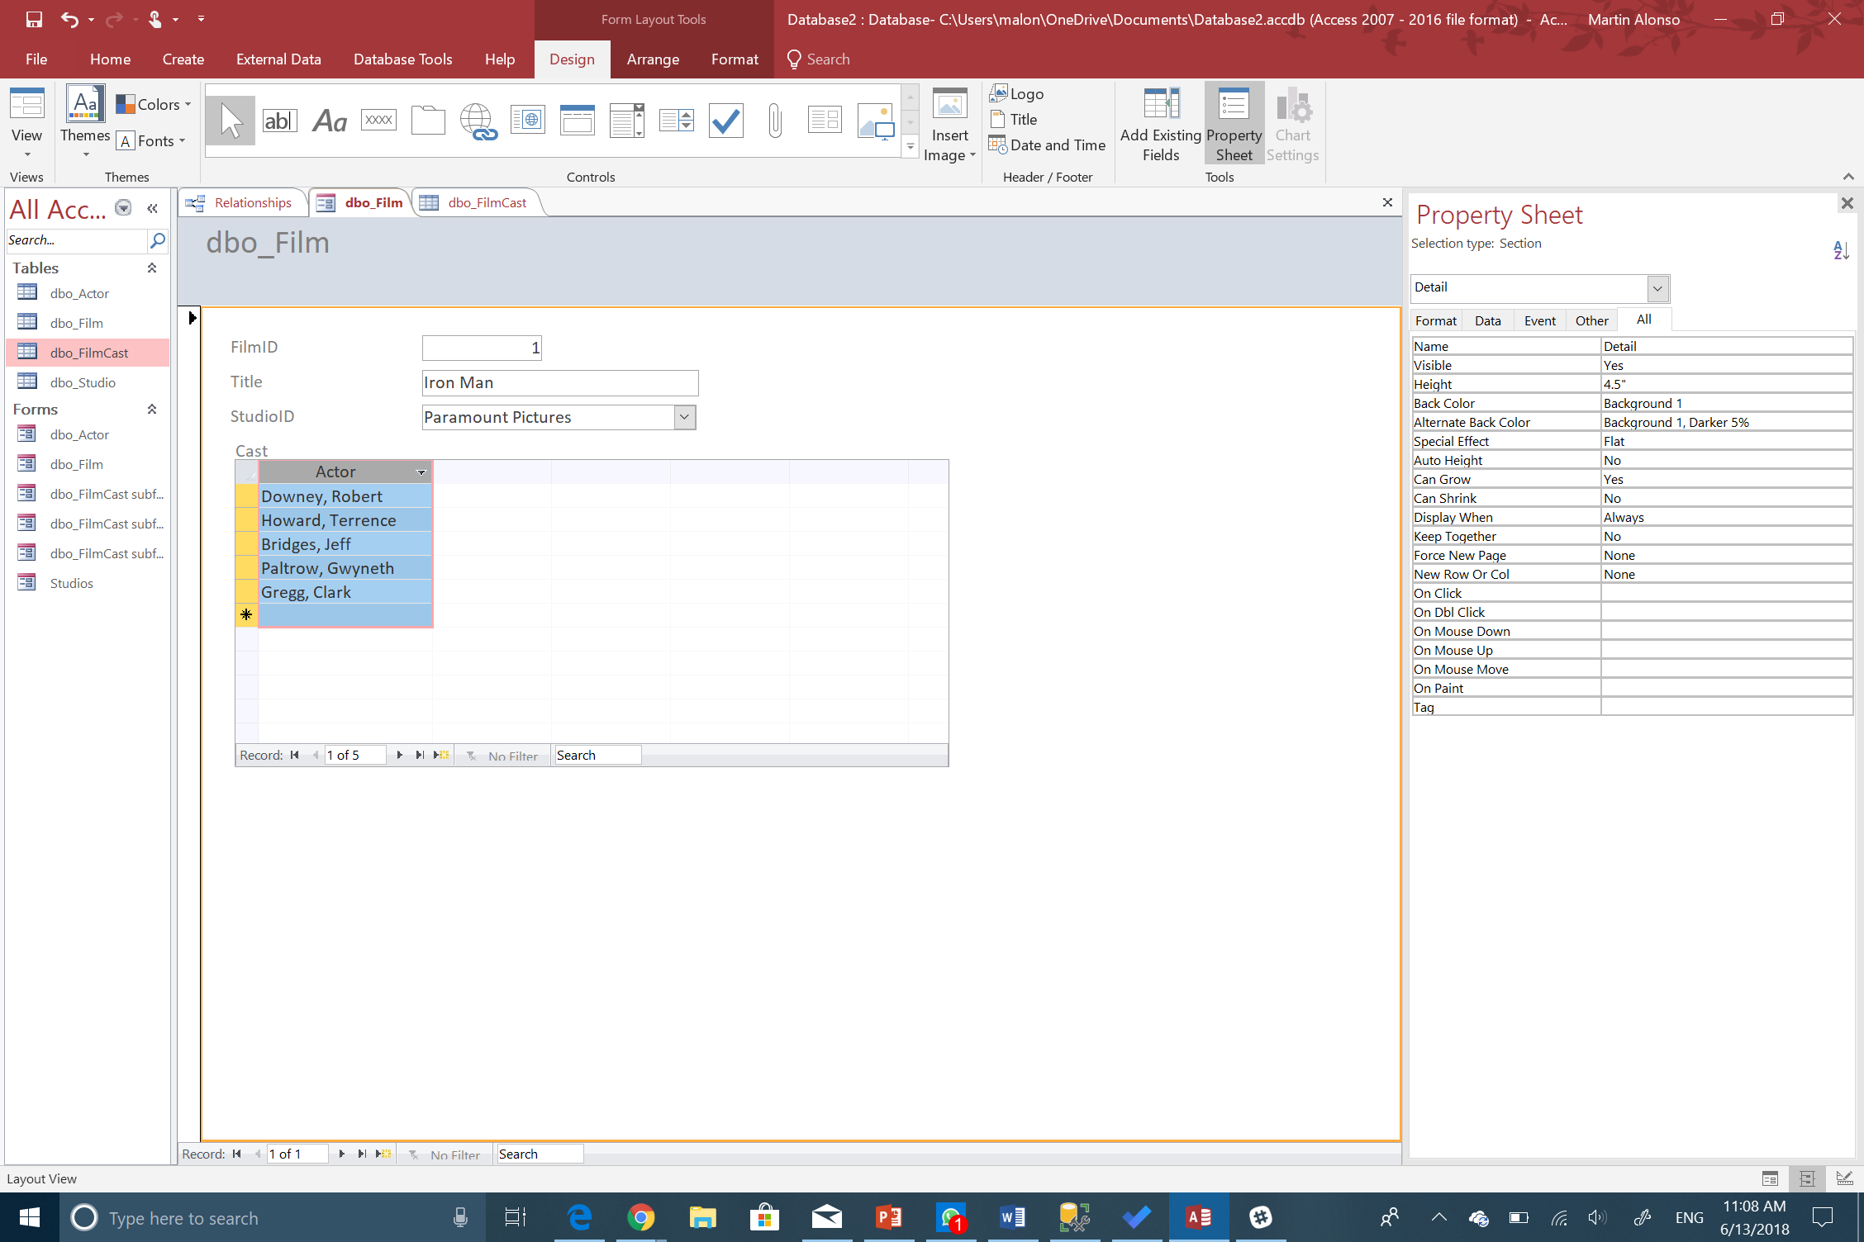

6. The Movie Report

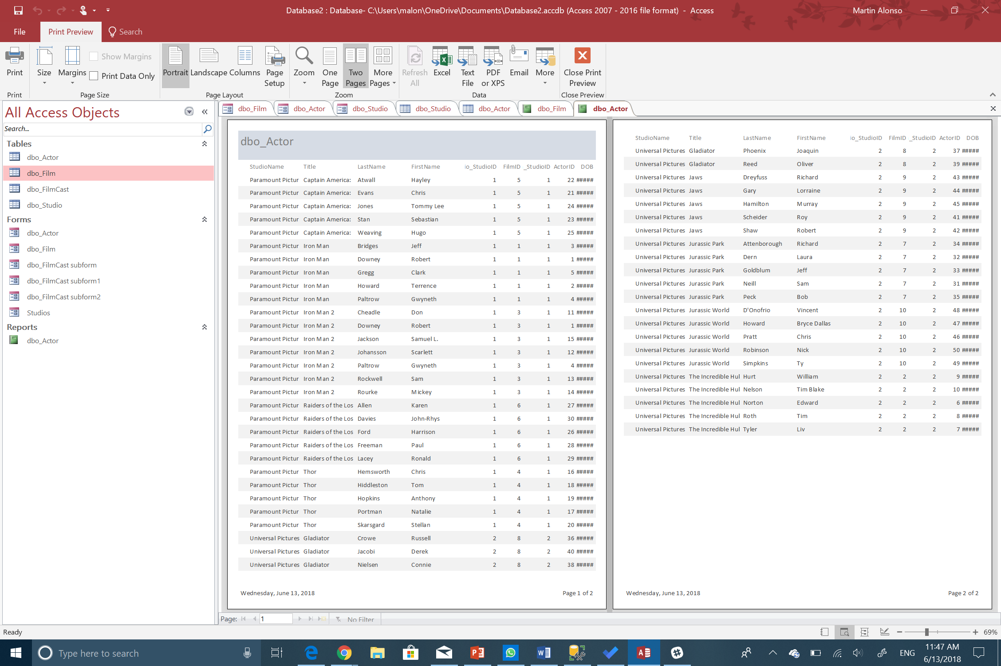

7. The view from SQL Server

